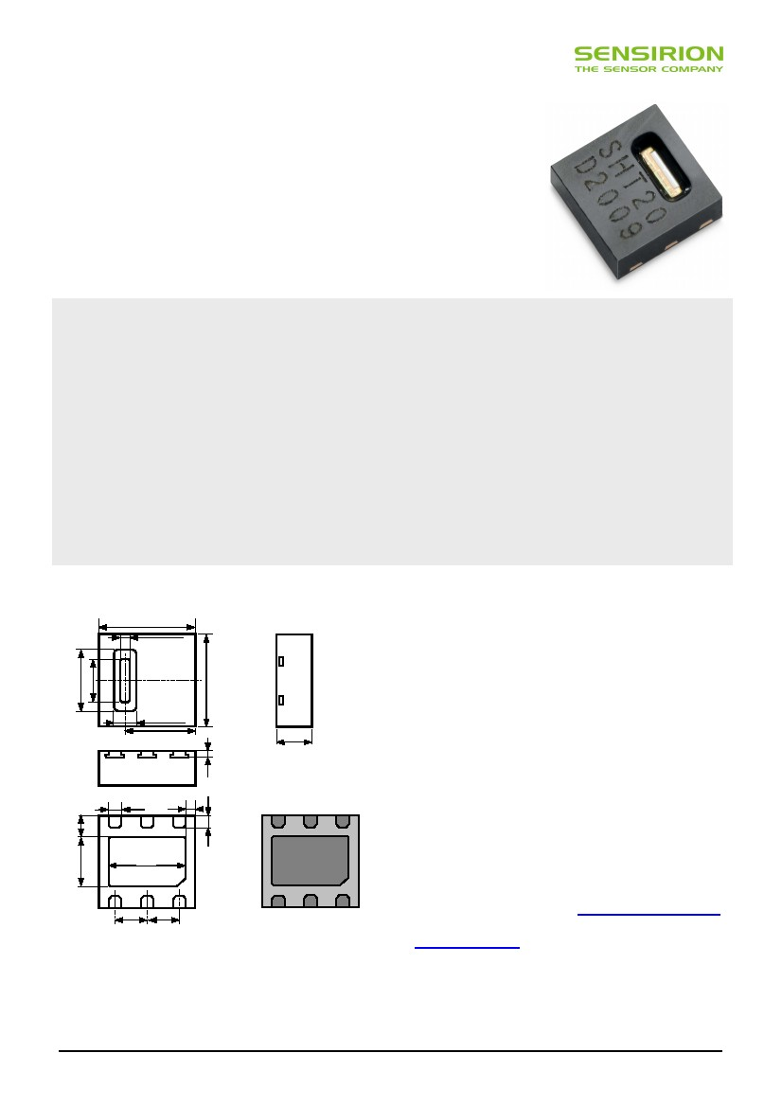
Datasheet SHT20
Humidity and Temperature Sensor
Fully calibrated
Digital output, I2C interface
Low power consumption
Excellent long term stability
DFN type package – reflow solderable
Product Summary
SHT20, the new humidity and temperature sensor of
Sensirion is about to set new standards in terms of size
and intelligence: Embedded in a reflow solderable Dual
Flat No leads (DFN) package of 3 x 3mm foot print and
1.1mm height it provides calibrated, linearized signals in
digital, true I2C format.
With a completely new designed CMOSens® chip, a
reworked capacitive type humidity sensor and a standard
band gap temperature sensor the performance has been
lifted even beyond the outstanding level of the previous
sensor generation (SHT1x and SHT7x). For example,
measures have been taken to stabilize the behavior at
high humidity levels.
Dimensions
3.0
0.3 typ
Every sensor is individually calibrated and tested. Lot
identification is printed on the sensor and an electronic
identification code is stored on the chip – which can be
read out by command. Furthermore, the resolution of
SHT20 can be changed by command (8/12bit up to
12/14bit for RH/T), low battery can be detected and a
checksum helps to improve communication reliability.
With made improvements and the miniaturization of the
sensor the performance-to-price ratio has been improved
– and eventually, any device should benefit from the
cutting edge energy saving operation mode. For testing
SHT20 a new evaluation Kit EK-H4 is available.
Sensor Chip
SHT20 features a generation 4C CMOSens® chip.
Besides the capacitive relative humidity sensor and the
band gap temperature sensor, the chip contains an
amplifier, A/D converter, OTP memory and a digital
processing unit.
1.1
0.2
SHT20D0AC4
0.8 typ
2.0 typ1.4 typ
3.0
2.2
Material Contents
While the sensor itself is made of Silicon the sensors’
housing consists of a plated Cu lead-frame and green
epoxy-based mold compound. The device is fully RoHS
and WEEE compliant, e.g. free of Pb, Cd and Hg.
Additional Information and Evaluation Kits
Additional information such as Application Notes is
available from the web page www.sensirion.com/SHT20.
For more information please contact Sensirion via
info@sensirion.com.
Bottom View
NC
VDD
SCL
0.4
0.75
0.3
0.4
1.5
2.4
1.0
1.0
NC
VSS
SDA
Figure 1: Drawing of SHT20 sensor package, dimensions are
given in mm (1mm = 0.039inch), tolerances are ±0.1mm. Die
pad (centre pad) is internally connected to VSS. NC are floating.
VSS = GND, SDA = DATA.
For SHT20 two Evaluation Kits are available: EK-H4, a
four-channel device with viewer software, which also
serves for data-logging, and a simple EK-H5 directly
connecting one sensor via USB port to a computer.
www.sensirion.com
Version 1.0 – January 2010
1/12

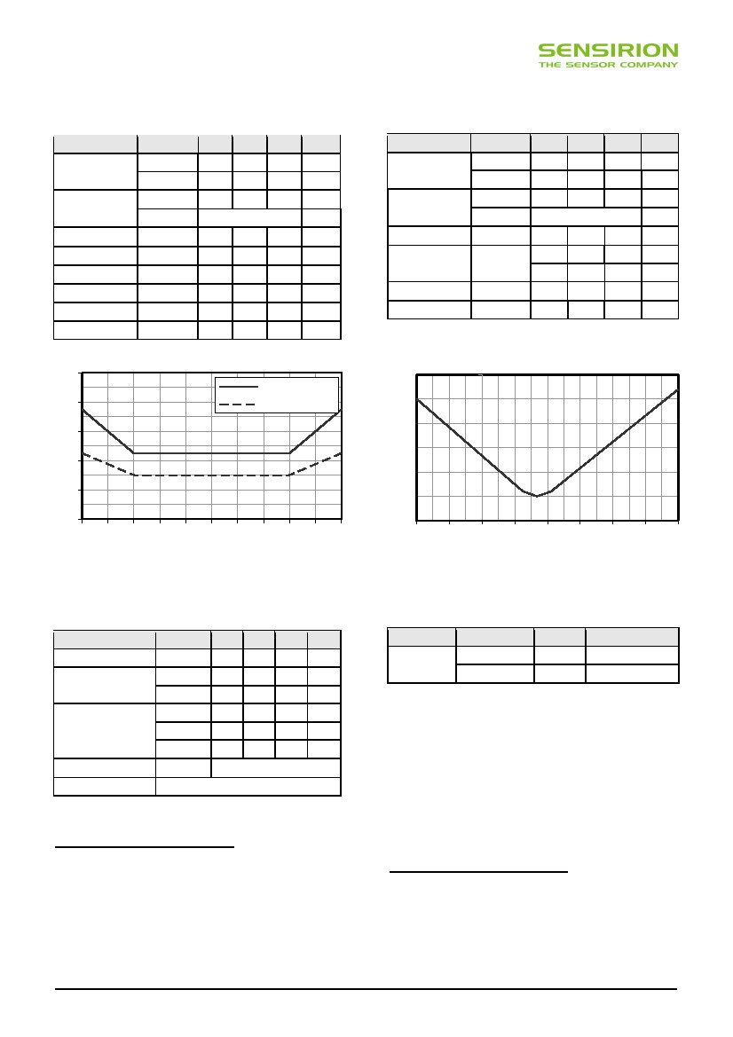
Sensor Performance
Relative Humidity1234
Parameter
Temperature567
min
Resolution 1
Condition
12 bit
8 bit
typ
0.04
0.7
max
Units
%RH
%RH
Parameter
Resolution 1
Condition
14 bit
12 bit
min
typ
0.01
0.04
max
Units
°C
°C
Accuracy
tolerance 2
typ
max
±3.0
see Figure 2
%RH
%RH
Accuracy
tolerance 2
typ
max
±0.5
see Figure 3
°C
°C
Repeatability
±0.1
%RH
Repeatability
±0.1
°C
Hysteresis
Nonlinearity
±1
<0.1
%RH
Operating Range extended 4
%RH
-40
-40
125
257
°C
°F
Response time 3
⎮ 63%
Operating Range extended 4
Long Term Drift 5normal
8
s
Response Time 7
⎮ 63%
5
30
s
0
100
< 0.5
%RH
%RH/yr
Long Term Drift
< 0.04
°C/yr
∆RH (%RH)
± 10
∆T (°C)
± 3.0
maximal tolerance
±8
±6
±4
typical tolerance
± 2.5
± 2.0
± 1.5
± 1.0
±2
±0
0
10
20
30
40
50
60 70 80 90 100
Relative Humidity (%RH)
± 0.5
± 0.0
-40
-20
0
20
40
60
80100120
Temperature (°C)
Figure 2 Typical and maximal tolerance at 25°C for relative
humidity. For extensive information see Users Guide, Sect. 1.2.
Figure 3 Maximal tolerance for temperature sensor in °C.
Electrical Specification
Conditions minParameter
Supply Voltage, VDD2.1
sleep mode-
Supply Current, IDD 6
measuring270
sleep mode-
6Power Dissipationmeasuring0.8
average 8bit-
Packaging Information
typ
3.0
0.15
300
0.5
0.9
1.5
max Units
3.6V
0.4A
330A
1.2W
1.0 mW
-W
Sensor Type
SHT20
Packaging
Tape & Reel
Tape & Reel
Quantity
1500
5000
Order Number
1-100706-01
1-100704-01
Heater
VDD = 3.0 V
Communication
5.5mW, ∆Τ = + 0.5-1.5°C
digital 2-wire interface, true I2C protocol
Table 1 Electrical specification. For absolute maximum
values see Chapter 3 of Users Guide.
1
This datasheet is subject to change and may be amended
without prior notice.
Default measurement resolution is 14bit (temperature) / 12bit (humidity). It can
be reduced to 12/8bit, 11/11bit or 13/10bit by command to user register.
2 Accuracies are tested at Outgoing Quality Control at 25°C (77°F) and 3.0V.
Values exclude hysteresis and non-linearity and are applicable to non-
condensing environments only.
3 Time for achieving 63% of a step function, valid at 25°C and 1 m/s airflow.
4 Normal operating range: 0-80%RH, beyond this limit sensor may read a
reversible offset with slow kinetics (<3%RH after 200hours at 90%RH). For more
details please see Section 1.1 of the Users Guide.
Value may be higher in environments with vaporized solvents, out-gassing
tapes, adhesives, packaging materials, etc. For more details please refer to
Handling Instructions.
6 Min and max values of Supply Current and Power Dissipation are based on
fixed VDD = 3.0V and T<60°C. The average value is based on one 8bit
measurement per second.
7 Response time depends on heat conductivity of sensor substrate.
5
www.sensirion.com
Version 1.0 – January 2010
2/12

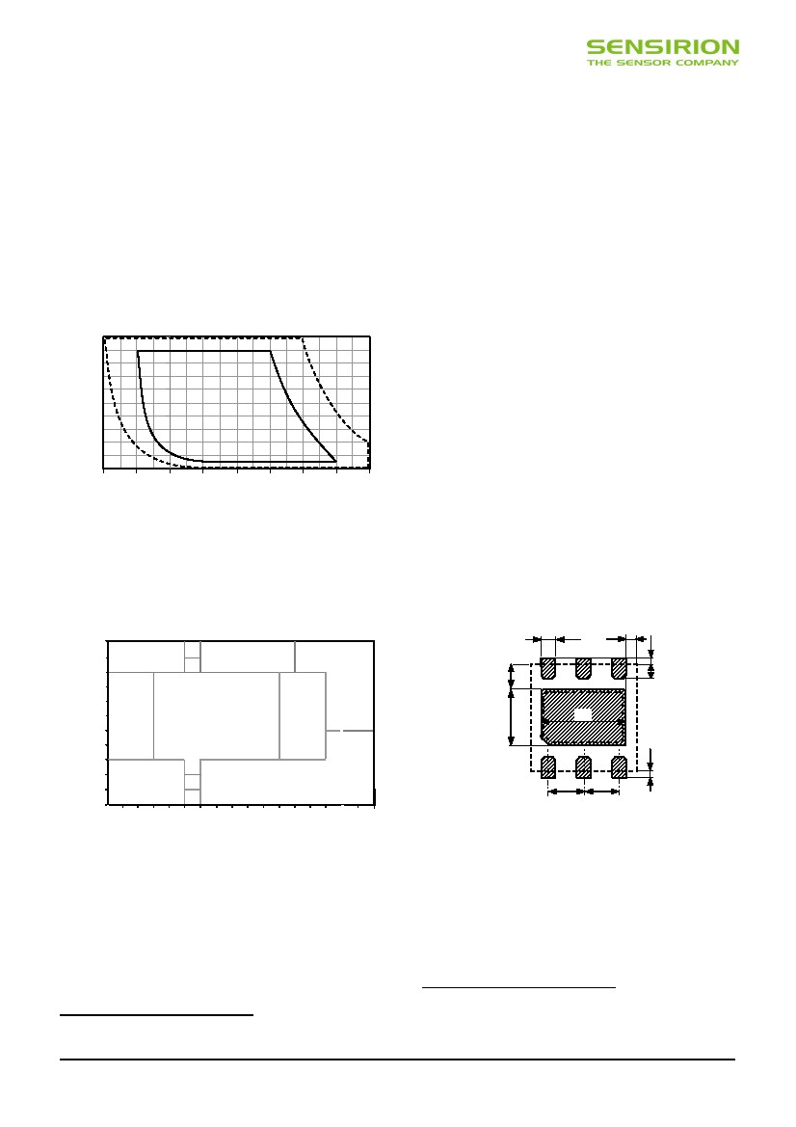
Datasheet SHT20
Users Guide SHT2x
1 Extended Specifications
1.1 Operating Range
The sensor works stable within recommended Normal
Range – see Figure 4. Long term exposure to conditions
outside Normal Range, especially at humidity >80%RH,
may temporarily offset the RH signal (+3%RH after 60h).
After return into the Normal Range it will slowly return
towards calibration state by itself. See Section 2.3 “Recon-
ditioning Procedure” for eliminating the offset. Prolonged
exposure to extreme conditions may accelerate ageing.
Relative Humidity (%)
2 Application Information
2.1 Soldering Instructions
The DFN’s die pad (centre pad) and perimeter I/O pads
are fabricated from a planar copper lead-frame by over-
molding leaving the die pad and I/O pads exposed for
mechanical and electrical connection. Both the I/O pads
and die pad should be soldered to the PCB. In order to
prevent oxidation and optimize soldering, the bottom side
of the sensor pads is plated with Ni/Pd/Au.
On the PCB the I/O lands9 should be 0.2mm longer than
the package I/O pads. Inward corners may be rounded to
match the I/O pad shape. The I/O land width should match
the DFN-package I/O-pads width 1:1 and the land for the
die pad should match 1:1 with the DFN package – see
Figure 6.
The solder mask10 design for the land pattern preferably is
of type Non-Solder Mask Defined (NSMD) with solder
mask openings larger than metal pads. For NSMD pads,
the solder mask opening should be about 120µm to
150µm larger than the pad size, providing a 60µm to 75µm
design clearance between the copper pad and solder
mask. Rounded portions of package pads should have a
matching rounded solder mask-opening shape to minimize
the risk of solder bridging. For the actual pad dimensions,
each pad on the PCB should have its own solder mask
opening with a web of solder mask between adjacent
pads.
0.4
0.3
100
80
60
40
20
0
-40
-20
0
20
40
60
80100 120
Temperature (°C)
Normal
Range
Max.
Range
Figure 4 Operating Conditions
1.2 RH accuracy at various temperatures
Maximal tolerance for RH accuracy at 25°C is defined in
Figure 2. For other temperatures maximal tolerance has
been evaluated to be within limits displayed in Figure 58.
100
90
80
70
60
50
40
30
20
10
0
Relative Humidity (%RH)
±7
±8
0.7
±6
±4.5
±6
1.6
2.4
±7
±5
±7
±7
1.0
1.0
0 5 10 15 20 25 30 35 40 45 50 55 60 65 70 75 80
Temperature (°C)
Figure 6 Recommended metal land pattern for SHT2x. Values
in mm. Die pad (centre pad) and NC pads may be left floating or
be connected to ground. The outer dotted line represents the
outer dimension of the DFN package.
Figure 5 Maximal tolerance of relative humidity measurements
given in %RH for temperatures 0 – 80°C.
Please note that above values are maximal tolerances (not
including hysteresis) against a high precision reference
such as a dew point mirror. Typical deviations are at
±3%RH where maximal tolerance is ±4.5%RH and about
half the maximal tolerance at other values.
8
For solder paste printing a laser-cut, stainless steel stencil
with electro-polished trapezoidal walls and with 0.125mm
stencil thickness is recommended. For the I/O pads the
stencil apertures should be 0.1mm longer than PCB pads
and positioned with 0.1mm offset away from the centre of
The land pattern is understood to be the metal layer on the PCB, onto which
the DFN pads are soldered to.
10 The solder mask is understood to be the insulating layer on top of the PCB
covering the connecting lines.
9
Details on how Sensirion is specifying and testing accuracy performance are
planned to be published on the Sensirion web page.
www.sensirion.com
Version 1.0 – January 2010
0.2
0.4
±7
±5
±7
0.2
3/12

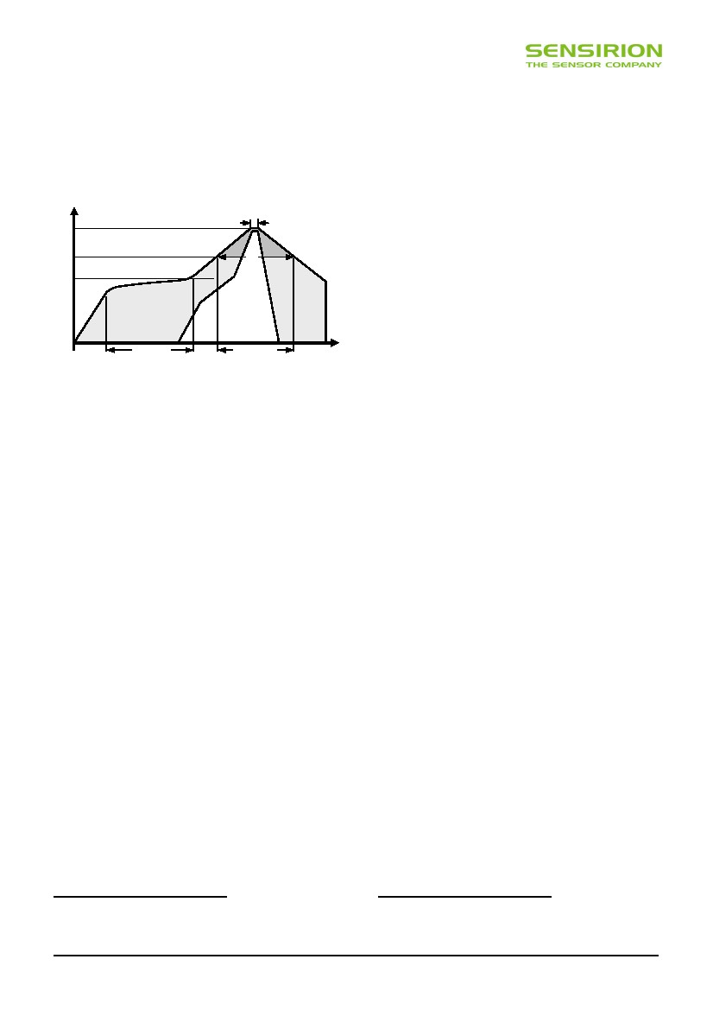
Datasheet SHT20
the package. The die pad aperture should cover about 70
– 90% of the pad area – say up to 1.4mm x 2.3mm
centered on the thermal land area. It can also be split in
two openings.
Due to the low mounted height of the DFN, “no clean”
type 3 solder paste11 is recommended as well as Nitrogen
purge during reflow.
TP
tP
It is of great importance to understand that a humidity
sensor is not a normal electronic component and needs to
be handled with care. Chemical vapors at high
concentration in combination with long exposure times
may offset the sensor reading.
For this reason it is recommended to store the sensors in
original packaging including the sealed ESD bag at
following conditions: Temperature shall be in the range of
10°C – 50°C and humidity at 20 – 60%RH (sensors that
are not stored in ESD bags). For sensors that have been
removed from the original packaging we recommend to
store them in ESD bags made of PE-HD13.
In manufacturing and transport the sensors shall be
prevented of high concentration of chemical solvents and
long exposure times. Out-gassing of glues, adhesive tapes
and stickers or out-gassing packaging material such as
bubble foils, foams, etc. shall be avoided. Manufacturing
area shall be well ventilated.
For more detailed information please consult the
document “Handling Instructions” or contact Sensirion.
2.3 Reconditioning Procedure
As stated above extreme conditions or exposure to solvent
vapors may offset the sensor. The following reconditioning
procedure may bring the sensor back to calibration state:
Baking:
Re-Hydration:
100 – 105°C at < 5%RH for 10h
20 – 30°C at ~ 75%RH for 12h 14.
Temperature
TL
TS (max)
tL
preheating
critical zone
Time
Figure 7 Soldering profile according to JEDEC standard. TP <=
260°C and tP < 40sec for Pb-free assembly. TL < 220°C and tL <
150sec. Ramp-up/down speeds shall be < 5°C/sec.
It is important to note that the diced edge or side faces of
the I/O pads may oxidise over time, therefore a solder fillet
may or may not form. Hence there is no guarantee for
solder joint fillet heights of any kind.
For soldering SHT2x, standard reflow soldering ovens may
be used. The sensor is qualified to withstand soldering
profile according to IPC/JEDEC J-STD-020D with peak
temperatures at 260°C during up to 40sec for Pb-free
assembly in IR/Convection reflow ovens (see Figure 7).
For manual soldering contact time must be limited to 5
seconds at up to 350°C12.
IMPORTANT: After soldering, the devices should be
stored at >75%RH for at least 12h to allow the sensor
element to re-hydrate. Otherwise the sensor may read an
offset that slowly disappears if exposed to ambient
conditions. Alternatively the re-hydration process may be
performed at ambient conditions (>40%RH) during more
than 5 days.
In no case, neither after manual nor reflow soldering, a
board wash shall be applied. Therefore, and as mentioned
above, it is strongly recommended to use “no-clean” solder
paste. In case of applications with exposure of the sensor
to corrosive gases the soldering pads shall be sealed to
prevent loose contacts or short cuts.
2.2 Storage Conditions and Handling Instructions
Moisture Sensitivity Level (MSL) is 2; hence storage time
is limited to one year.
Solder types are related to the solder particle size in the paste: Type 3 covers
the size range of 25 – 45 m (powder type 42).
12 260°C = 500°F, 350°C = 662°F
11
2.4 Temperature Effects
Relative humidity reading strongly depends on
temperature. Therefore, it is essential to keep humidity
sensors at the same temperature as the air of which the
relative humidity is to be measured. In case of testing or
qualification the reference sensor and test sensor must
show equal temperature to allow for comparing humidity
readings.
If the sensor shares a PCB with electronic components
that produce heat it should be mounted in a way that
prevents heat transfer or keeps it as low as possible.
Measures to reduce heat transfer can be ventilation,
reduction of copper layers between the sensor and the
rest of the PCB or milling a slit into the PCB around the
sensor – see Figure 8.
Furthermore, there are self-heating effects in case the
measurement frequency is too high. To keep self heating
below 0.1°C, SHT2x should not be active for more than
10% of the time – e.g. maximum two measurements per
second at 12bit accuracy shall be made.
13
14
For example, 3M antistatic bag, product “1910” with zipper.
75%RH can conveniently be generated with saturated NaCl solution.
100 – 105°C correspond to 212 – 221°F, 20 – 30°C correspond to 68 – 86°F
www.sensirion.com
Version 1.0 – January 2010
4/12

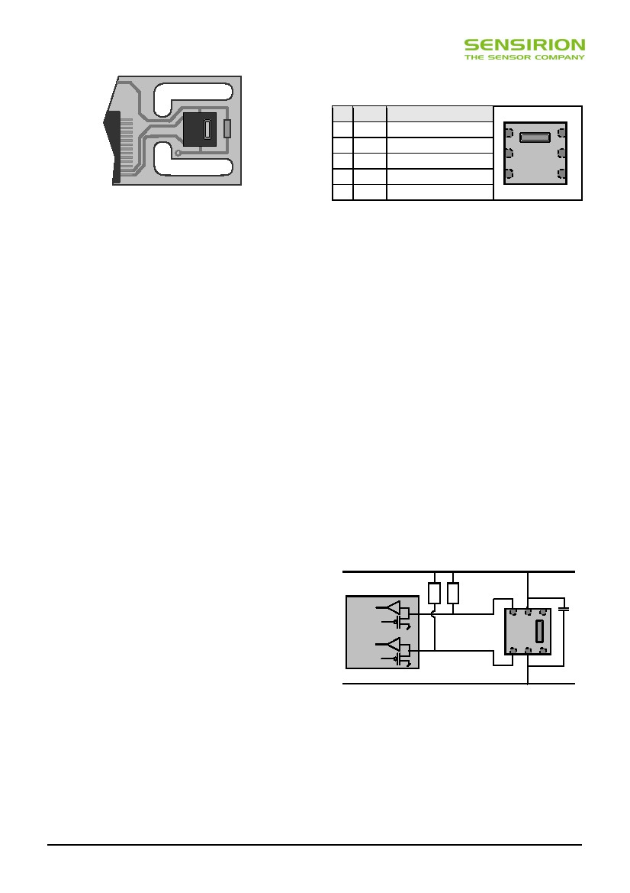
Datasheet SHT20
3 Interface Specifications
CommentPin Name
2VSS Ground
4
1SDA Serial Data, bidirectional
5
6SCL Serial Clock, bidirectional
65 VDD Supply Voltage
3,4 NC Not Connected, floating
3
2
1
Figure 8 Top view of example of mounted SHT2x with slits
milled into PCB to minimize heat transfer.
Table 2 SHT2x pin assignment, NC remain floating
2.5 Light
The SHT2x is not light sensitive. Prolonged direct
exposure to sunshine or strong UV radiation may age the
sensor.
2.6 Materials Used for Sealing / Mounting
Many materials absorb humidity and will act as a buffer
increasing response times and hysteresis. Materials in the
vicinity of the sensor must therefore be carefully chosen.
Recommended materials are: Any metals, LCP, POM
(Delrin), PTFE (Teflon), PEEK, PP, PB, PPS, PSU, PVDF,
PVF.
For sealing and gluing (use sparingly): Use high filled
epoxy for electronic packaging (e.g. glob top, underfill),
and Silicone. Out-gassing of these materials may also
contaminate the sensor (see Section 1.3). Therefore try to
add the sensor as a last manufacturing step to the
assembly, store the assembly well ventilated after
manufacturing or bake at >50°C for 24h to outgas
contaminants before packing.
2.7 Wiring Considerations and Signal Integrity
Carrying the SCL and SDA signal parallel and in close
proximity (e.g. in wires) for more than 10cm may result in
cross talk and loss of communication. This may be
resolved by routing VDD and/or VSS between the two
SDA signals and/or using shielded cables. Furthermore,
slowing down SCL frequency will possibly improve signal
integrity. Power supply pins (VDD, VSS) must be
decoupled with a 100nF capacitor – see next Section.
3.1 Power Pins (VDD, VSS)
The supply voltage of SHT2x must be in the range of 2.1 –
3.6V, recommended supply voltage is 3.0V. Power supply
pins Supply Voltage (VDD) and Ground (VSS) must be
decoupled with a 100nF capacitor, that shall be placed as
close to the sensor as possible – see Figure 9.
3.2 Serial clock (SCL)
SCL is used to synchronize the communication between
microcontroller (MCU) and the sensor. Since the interface
consists of fully static logic there is no minimum SCL
frequency.
3.3 Serial SDA (SDA)
The SDA pin is used to transfer data in and out of the
sensor. For sending a command to the sensor, SDA is
valid on the rising edge of SCL and must remain stable
while SCL is high. After the falling edge of SCL the SDA
value may be changed. For safe communication SDA shall
be valid tSU and tHD before the rising and after the falling
edge of SCL, respectively – see Figure 10. For reading
data from the sensor, SDA is valid tVD after SCL has gone
low and remains valid until the next falling edge of SCL.
VDD
MCU (master)
RP
RP
SCL
SCL IN
SCL OUT
SDA IN
SDA OUT
C = 100nF
SHT2x
(slave)
SDA
GND
Figure 9 Typical application circuit, including pull-up resistors
RP and decoupling of VDD and VSS by a capacitor.
To avoid signal contention the micro-controller unit (MCU)
must only drive SDA and SCL low. External pull-up
resistors (e.g. 10k ), are required to pull the signal high.
For the choice of resistor size please take bus capacity
requirements into account (compare Table 5). It should be
noted that pull-up resistors may be included in I/O circuits
www.sensirion.com
Version 1.0 – January 2010
5/12

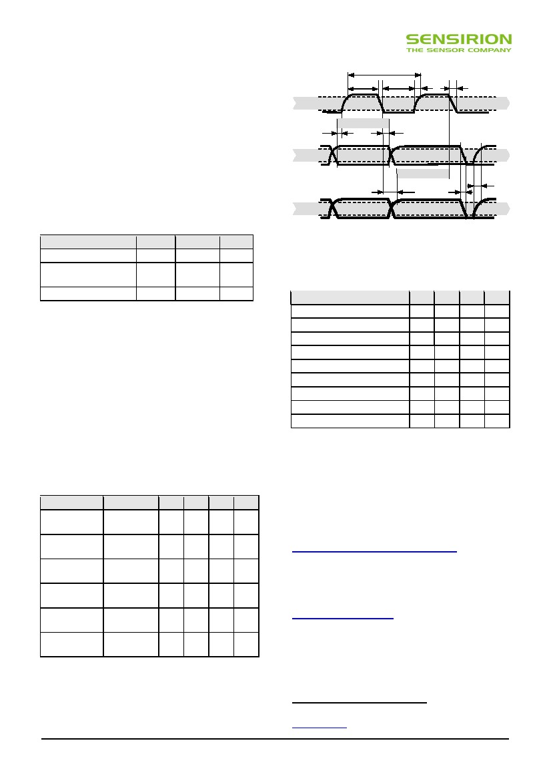
Datasheet SHT20
of MCUs. See Table 4 and Table 5 for detailed I/O
characteristic of the sensor.
1/fSCK
tSCKH
tSCKL
tR
tF
70%
4 Electrical Characteristics
4.1 Absolute Maximum Ratings
The electrical characteristics of SHT2x are defined in
Table 1. The absolute maximum ratings as given in Table
3 are stress ratings only and give additional information.
Functional operation of the device at these conditions is
not implied. Exposure to absolute maximum rating
conditions for extended periods may affect the sensor
reliability (e.g. hot carrier degradation, oxide breakdown).
Parameter
VDD to VSS
Digital IO Pins (SDA, SCL)
to VSS
Input Current on any Pin
SCL
tSU
DATA IN
30%
SDA valid write
tHD
70%
SDA
SDA valid read
30%
tVD
DATA OUT
tF
tR
SDA
70%
30%
min
-0.3
max
5
Units
V
-0.3
VDD + 0.3
V
Figure 10 Timing Diagram for Digital Input/Output Pads,
abbreviations are explained in Table 5. SDA directions are seen
from the sensor. Bold SDA line is controlled by the sensor, plain
SDA line is controlled by the micro-controller. Both valid times
(SDA read and SDA write) refer to the left SCL toggle.
-100
100
mA
Table 3 Electrical absolute maximum ratings
ESD immunity is qualified according to MIL STD 883E,
method 3015 (Human Body Model at ±2 kV). Latch-up
immunity is provided at a force current of ±100μΑ with
Tamb = 80°C according to JEDEC78A. For exposure
beyond named limits the sensor needs additional
protection circuit.
4.2 Input / Output Characteristics
The electrical characteristics such as power consumption,
low and high level input and output voltages depend on
the supply voltage. For proper communication with the
sensor it is essential to make sure that signal design is
strictly within the limits given in Table 4 & 5 and Figure 10.
Parameter
Parameter
SCL frequency, fSCL
SCL High Time, tSCLH
SCL Low Time, tSCLL
SDA Set-Up Time, tSU
SDA Hold Time, tHD
SDA Valid Time, tVD
SCL/SDA Fall Time, tF
SCL/SDA Rise Time, tR
Capacitive Load on Bus Line, CB
min
0
0.6
1.3
100
0
0
0
0
0
typ
-
-
-
-
-
-
-
-
-
max
0.4
-
-
-
900
400
100
300
400
Units
MHz
s
s
ns
ns
ns
ns
ns
pF
Table 5 Timing specifications of digital input/output pads for I2C
fast mode. Entities are displayed in Figure 10. VDD = 2.1V to
3.6V, T = -40°C to 125°C, unless otherwise noted.
5 Communication with Sensor
Conditions
VDD = 3.0 V,
-4 mA < IOL < 0mA
min
typ
max
Units
Output Low
Voltage, VOL
0
-
0.4
V
Output High
Voltage, VOH
70%
VDD
-
VDD
V
Output Sink
Current, IOL
-
-
-4
mA
SHT20 communicates with true I2C protocol. For
information on I2C beyond the information in the following
Sections please refer to the following website:
http://www.standardics.nxp.com/support/i2c/.
Please note that all sensors are set to the same I2C
address, as defined in Section 5.3. 15
Input Low
Voltage, VIL
0
-
30%
VDD
V
Input High
Voltage, VIH
70%
VDD
VDD = 3.6 V,
VIN = 0 V to 3.6 V
-
VDD
V
Furthermore, please note, that Sensirion provides a
sample code on its home page – compare
www.sensirion.com/SHT20.
Input Current
-
-
±1
uA
Table 4 DC characteristics of digital input/output pads. VDD =
2.1 V to 3.6 V, T = -40 °C to 125 °C, unless otherwise noted.
5.1 Start Up Sensor
As a first step, the sensor is powered up to the chosen
supply voltage VDD (between 2.1 V and 3.6 V). After
power-up, the sensor needs at most 15 ms, while SCL is
high, for reaching idle state, i.e. to be ready accepting
15 For sensors with alternative I2C address please contact Sensirion via
info@sensirion.com.
www.sensirion.com
Version 1.0 – January 2010
6/12

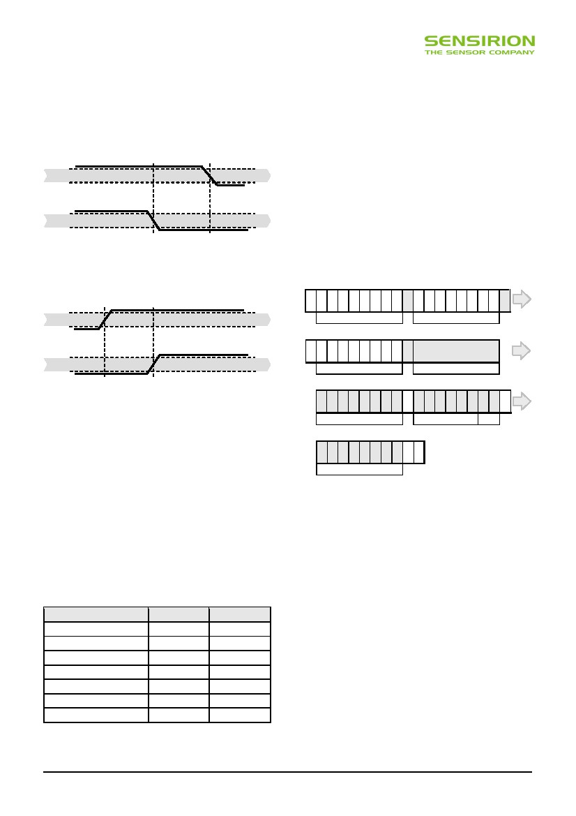
Datasheet SHT20
commands from the master (MCU). Current consumption
during start up is 350 A maximum.
5.2 Start / Stop Sequence
Each transmission sequence begins with Start condition
(S) and ends with Stop condition (P) as displayed in Figure
11 and Figure 12.
SCL
70%
30%
5.4 Hold / No Hold Master Mode
There are two different operation modes to communicate
with the sensor: Hold Master mode or No Hold Master
mode. In the first case the SCL line is blocked (controlled
by sensor) during measurement process while in the latter
case the SCL line remains open for other communication
while the sensor is processing the measurement. No hold
master mode allows for processing other I2C
communication tasks on a bus while the sensor is
measuring. A communication sequence of the two modes
is displayed in Figure 13 and Figure 14, respectively.
In the hold master mode, the SHT2x pulls down the SCL
line while measuring to force the master into a wait state.
By releasing the SCL line the sensor indicates that internal
processing is terminated and that transmission may be
continued.
1
2
3
4
5
6
7
8
9
10 11 12 13 14 15 16 17 18
SDA
70%
30%
ACK
S10000000
11100101
Command (see Table 6)
SCL
70%
I2C address + write
19 20 21 22 23 24 25 26 27
30%
ACK
SDA
70%
S10000001
I2C address + read
Measurement
Hold during measurement
30%
Figure 12 Transmission Stop Condition (P) - a low to high
transition on the SDA line while SCL is high. The Stop condition
is a unique state on the bus created by the master, indicating to
the slaves the end of a transmission sequence (bus is
considered free after a Stop).
28 29 30 31 32 33 34 35 36 37 38 39 40 41 42 43 44 45
ACK
01100011
Data (MSB)
01010010
Data (LSB) Stat.
46 47 48 49 50 51 52 53 54
5.3 Sending a Command
After sending the Start condition, the subsequent I2C
header consists of the 7-bit I2C device address ‘1000’000’
and an SDA direction bit (Read R: ‘1’, Write W: ‘0’). The
sensor indicates the proper reception of a byte by pulling
the SDA pin low (ACK bit) after the falling edge of the 8th
SCL clock. After the issue of a measurement command
(‘1110’0011’ for temperature, ‘1110’0101’ for relative
humidity’), the MCU must wait for the measurement to
complete. The basic commands are summarized in Table
6. Hold master or no hold master modes are explained in
next Section.
Command
01100011
Checksum
NACK
P
Figure 13 Hold master communication sequence – grey blocks
are controlled by SHT2x. Bit 45 may be changed to NACK
followed by Stop condition (P) to omit checksum transmission.
Comment
Code
Trigger T measurement
Trigger RH measurement
Trigger T measurement
Trigger RH measurement
Write user register
Read user register
Soft reset
hold master
hold master
no hold master
no hold master
1110’0011
1110’0101
1111’0011
1111’0101
1110’0110
1110’0111
1111’1110
In no hold master mode, the MCU has to poll for the
termination of the internal processing of the sensor. This is
done by sending a Start condition followed by the I2C
header (1000’0001) as shown in Figure 14. If the internal
processing is finished, the sensor acknowledges the poll of
the MCU and data can be read by the MCU. If the
measurement processing is not finished the sensor
answers no ACK bit and the Start condition must be
issued once more.
For both modes, since the maximum resolution of a
measurement is 14 bit, the two last LSBs (bits 43 and 44)
are used for transmitting status information. Bit 1 of the
two LSBs indicates the measurement type (‘0’:
temperature, ‘1’ humidity). Bit 0 is currently not assigned.
Table 6 Basic command set, RH stands for relative humidity,
and T stands for temperature
www.sensirion.com
Version 1.0 – January 2010
ACK
7/12
ACK
Figure 11 Transmission Start Condition (S) - a high to low
transition on the SDA line while SCL is high. The Start condition
is a unique state on the bus created by the master, indicating to
the slaves the beginning of a transmission sequence (bus is
considered busy after a Start).

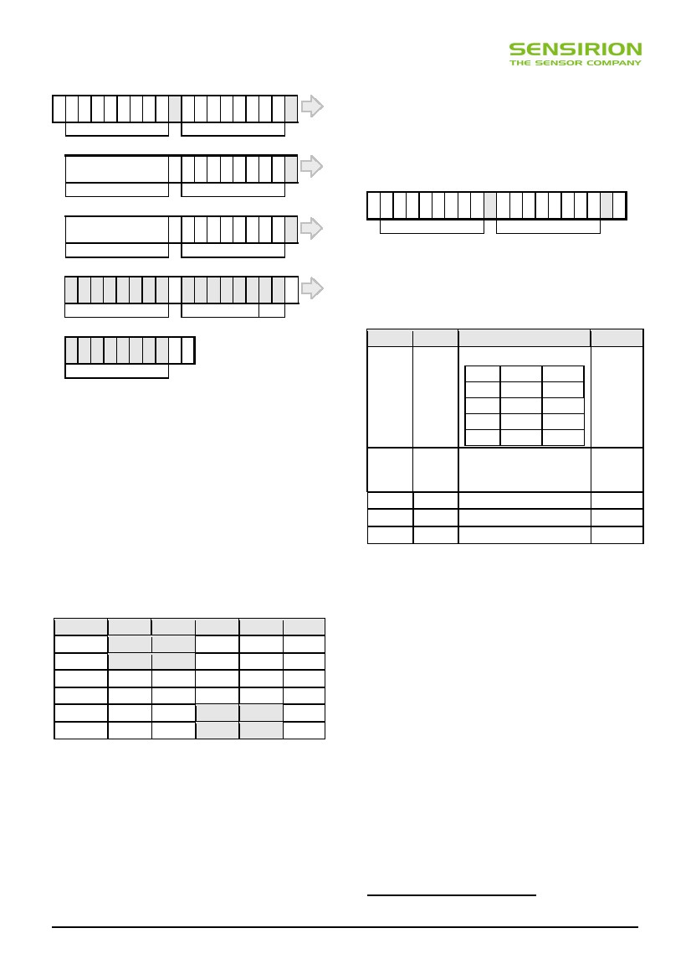
Datasheet SHT20
1
2
3
4
5
6
7
8
9
10 11 12 13 14 15 16 17 18
S10000000
I2C address + write
11110101
Command (see Table 6)
19 20 21 22 23 24 25 26 27
Measurement
measuring
S10000001
I2C address + read
NACK
5.5 Soft Reset
This command (see Table 6) is used for rebooting the
sensor system without switching the power off and on
again. Upon reception of this command, the sensor
system reinitializes and starts operation according to the
default settings. The soft reset takes less than 15 ms.
1
2
3
4
5
6
7
8
9
10 11 12 13 14 15 16 17 18
ACK
ACK
ACK
ACK
19 20 21 22 23 24 25 26 27
S10000000
I2C address + write
11111110
Soft Reset
P
Measurement
continue measuring
S10000001
I2C address + read
ACK
Figure 15 Soft Reset – grey blocks are controlled by SHT2x.
28 29 30 31 32 33 34 35 36 37 38 39 40 41 42 43 44 45
01100011
Data (MSB)
01010010
Data (LSB) Stat.
5.6 User Register
The content of user register is described in Table 8.
Please note that reserved bits must not be changed.
Bit
7, 0
46 47 48 49 50 51 52 53 54
ACK
ACK
01100011
Checksum
NACK
P
# Bits
2
Description / Coding
Measurement resolution
Default
‘00’
Figure 14 No Hold master communication sequence – grey
blocks are controlled by SHT2x. If measurement is not
completed upon “read” command, sensor does not provide ACK
on bit 27 (more of these iterations are possible). If bit 45 is
changed to NACK followed by Stop condition (P) checksum
transmission is omitted.
‘00’
‘01’
‘10’
‘11’
RH
12 bit
8 bit
10 bit
11 bit
T
14 bit
12 bit
13 bit
11 bit
6
1
In the examples given in Figure 13 and Figure 14 the
sensor output is SRH = ‘0110’0011’0101’0000’. For the
calculation of physical values Status Bits must be set to ‘0’
– see Chapter 6.
The maximum duration for measurements depends on the
type of measurement and resolution chosen – values are
displayed in Table 7. Maximum values shall be chosen for
the communication planning of the MCU.
Resolution
14 bit
13 bit
12 Bit
11 bit
10 bit
8 bit
3, 4, 5
2
1
3
1
1
Status: End of battery16
‘0’: VDD > 2.25 V
‘1’: VDD < 2.25 V
Reserved
Enable on-chip heater
Disable OTP reload
‘0’
‘0’
‘1’
Table 8 User Register. Cut-off value for End of Battery signal
may vary by ±0.05V. Reserved bits must not be changed. “OTP
reload” = ‘0’ loads default settings after each time a
measurement command is issued.
RH typ
RH max
22
12
7
3
29
15
9
4
T typ
66
33
17
9
T max
85
43
22
11
Units
ms
ms
ms
ms
ms
ms
The End of Battery alert is activated when the battery
power falls below 2.25V.
The heater is intended to be used for functionality
diagnosis – relative humidity drops upon rising
temperature. The heater consumes about 5.5mW and
provides a temperature increase of about 0.5 – 1.5°C.
OTP Reload is a safety feature and loads the entire OTP
settings to the register before every measurement. This
feature is disabled per default and is not recommended for
use. Please use Soft Reset instead – it contains OTP
Reload.
An example for I2C communication reading and writing the
User Register is given in Figure 16. It is important that first
the content of the register is read in order getting the
default values. Hereafter, the resolution is changed by
configuring register. Please note that the reserved user-
register bits must not be changed.
16
Table 7 Measurement times for RH and T measurements at
different resolutions. Typical values are recommended for
calculating energy consumption while maximum values shall be
applied for calculating waiting times in communication.
Please note: I2C communication allows for repeated Start
conditions (S) without closing prior sequence with Stop
condition (P) – compare Figures 13, 14 and 16. Still, any
sequence with adjacent Start condition may alternatively
be closed with a Stop condition.
This status bit is updated after each measurement
www.sensirion.com
Version 1.0 – January 2010
8/12

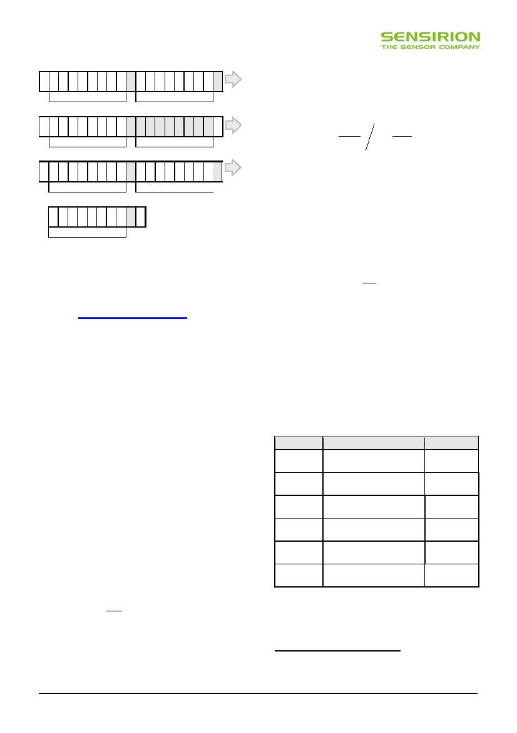
Datasheet SHT20
1
2
3
4
5
6
7
8
9
10 11 12 13 14 15 16 17 18
S10000000
I2C address + write
11100111
Read Register
19 20 21 22 23 24 25 26 27 28 29 30 31 32 33 34 35 36
Meteorological Organization (WMO). For relative humidity
above ice RHi the values need to be transformed from
relative humidity above water RHw at temperature t. The
equation is given in the following, compare also
Application Note “Introduction to Humidity:
 β ⋅t 
RH i = RH w ⋅ exp w 
 λ +t w
 β ⋅t 
exp i 
 λ +t i
ACK
S10000001
I2C address + read
00000010
Register content
37 38 39 40 41 42 43 44 45 46 47 48 49 50 51 52 53 54
NACK
ACK
ACK
S10000000
I2C address + write
11100110
Write Register
55 56 57 58 59 60 61 62 63
Units are %RH for relative humidity and °C for
temperature. The corresponding coefficients are defined
as follows: βw = 17.62, λw = 243.12°C, βi = 22.46, λi =
272.62°C.
ACK
ACK
00000011
Register content to be written
P
ACK
Figure 16 Read and write register sequence – grey blocks are
controlled by SHT2x. In this example, the resolution is set to 8bit
/ 12bit.
6.2 Temperature Conversion
The temperature T is calculated by inserting temperature
signal output ST into the following formula (result in °C), no
matter which resolution is chosen:
5.7 CRC Checksum
For implementing CRC8 checksum please refer to
Wikipedia (http://en.wikipedia.org/wiki/crc8).
T = − 46.85 + 175.72 ⋅
ST
216
7 Environmental Stability
The SHT2x sensor series were tested according to AEC-
Q100 Rev. F qualification test method. Sensor
specifications are tested to prevail under the AEC-Q100
temperature grade 2 test conditions listed in Table 917.
Sensor performance under other test conditions cannot be
guaranteed and is not part of the sensor specifications.
Especially, no guarantee can be given for sensor
performance in the field or for customer’s specific
application.
Environment Standard
HTSL125°C, 1000 hours
5.8 Serial Number
SHT20 provides an electronic identification code. For
instructions on how to read the identification code please
refer to the Application Note “Electronic Identification
Code” – to be downloaded from the web page
www.sensirion.com/SHT20.
6 Conversion of Signal Output
Default resolution is set to 12 bit relative humidity and 14
bit temperature reading. Measured data are transferred in
two byte packages, i.e. in frames of 8 bit length where the
most significant bit (MSB) is transferred first (left aligned).
Each byte is followed by an acknowledge bit. The two
status bits, the last bits of LSB, must be set to ‘0’ before
calculating physical values. In the example of Figure 13
and Figure 14, the transferred 16 bit relative humidity data
is ‘0110’0011’0101’0000’ = 25424.
6.1 Relative Humidity Conversion
With the relative humidity signal output SRH the relative
humidity RH is obtained by the following formula (result in
%RH), no matter which resolution is chosen:
TC
UHST
-50°C - 125°C, 1000 cycles
Acc. JESD22-A104-C
130°C / 85%RH, 96h
THU
85°C / 85%RH, 1000h
ESD immunity MIL STD 883E, method 3015
(Human Body Model at ±2kV)
Latch-upforce current of ±100mA with Qualified
Tamb = 80°C, acc. JEDEC 17
Results18
Within
specifications
Within
specifications
Within
specifications
Within
specifications
Qualified
S
RH = − 6 + 125 ⋅ RH
216
In the example given in Figure 13 and Figure 14 the
relative humidity results to be 42.5%RH.
The physical value RH given above corresponds to the
relative humidity above liquid water according to World
Table 9: Qualification tests: HTSL = High Temperature Storage
Lifetime, TC = Temperature Cycles, UHST = Unbiased Highly
accelerated Stress Test, THU = Temperature Humidity
Unbiased.
17
Sensor operation temperature range is -40 to 105°C according to AEC-Q100
temperature grade 2.
18 According to accuracy and long term drift specification given on Page 2.
www.sensirion.com
Version 1.0 – January 2010
9/12

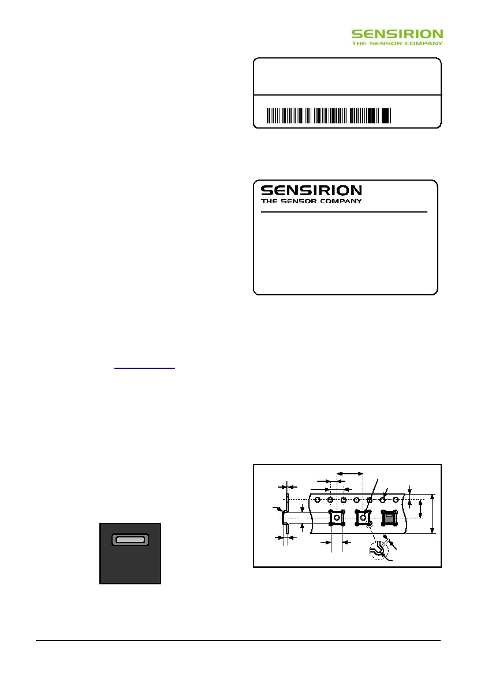
Datasheet SHT20
If sensors are qualified for reliability and behavior in
extreme conditions, please make sure that they
experience same conditions as the reference sensor. It
should be taken into account that response times in
assemblies may be longer, hence enough dwell time for
the measurement shall be granted. For detailed
information please consult Application Note “Qualification
Guide”.
Lot No.:
Quantity:
RoHS:
Lot No.
XXO-NN-YRRRRTTTT
RRRR
Compliant
8 Packaging
8.1
Packaging Type
SHT2x sensors are provided in DFN packaging (in
analogy with QFN packaging). DFN stands for Dual Flat
No leads.
The sensor chip is mounted to a lead frame made of Cu
and plated with Ni/Pd/Au. Chip and lead frame are over
molded by green epoxy-based mold compound. Please
note that side walls of sensors are diced and hence lead
frame at diced edge is not covered with respective
protective coating. The total weight of the sensor is 25mg.
Figure 18: First label on reel: XX = Sensor Type (20 for SHT20),
O = Output mode (D = Digital, P = PWM, S = SDM), NN = Chip
Version, Y = last digit of year, RRRR = number of sensors on
reel, TTTT = Traceability Code.
1-100PPP-NN
Humidity & Temperature Sensor
SHTxx
Part Order No. 1-100PPP-NN or Customer Number
Date of Delivery: DD.MM.YYYY
Order Code:45CCCC / 0
Device Type:
Description:
8.2 Filter Cap and Sockets
For SHT2x a filter cap SF2 will be provided. It is designed
for fast response times and compact size. Please find the
datasheet on Sensirion’s web page by February 2010.
For testing of SHT2x sensors sockets, such as from
Plastronics, part number 10LQ50S13030 are
recommended (see e.g. www.locknest.com).
Figure 19: Second label on reel: For Device Type and Part
Order Number (See Packaging Information on page 2), Delivery
Date (also Date Code) is date of packaging of sensors (DD =
day, MM = month, YYYY = year), CCCC = Sensirion order
number.
8.3 Traceability Information
All SHT2x are laser marked with an alphanumeric, five-
digit code on the sensor – see Figure 17.
The marking on the sensor consists of two lines with five
digits each. The first line denotes the sensor type
(SHT20). The first digit of the second line defines the
output mode (D = digital, Sensibus and I2C, P = PWM, S =
SDM). The second digit defines the manufacturing year (0
= 2010, 1 = 2011, etc.). The last three digits represent an
alphanumeric tracking code. That code can be decoded by
Sensirion only and allows for tracking on batch level
through production, calibration and testing – and will be
provided upon justified request.
8.4 Shipping Package
SHT2x are provided in tape & reel shipment packaging,
sealed into antistatic ESD bags. Standard packaging sizes
are 1500 and 5000 units per reel. For SHT20, each reel
contains 440mm (55 pockets) header tape and 200mm (25
pockets) trailer tape.
The drawing of the packaging tapes with sensor
orientation is shown in Figure 20. The reels are provided in
sealed antistatic bags.
8.0
0.3
R0.3 MAX
3.3
2.0
4.0
1.75
5.5
3.3
0.25
R0.25
Ø0.15 MIN
Ø0.15 MIN
1.3
SHT20
D0AC4
Figure 17 Laser marking on SHT20. For details see text.
Figure 20 Sketch of packaging tape and sensor orientation.
Header tape is to the right and trailer tape to the left on this
sketch.
Reels are also labeled, as displayed in Figure 18 and
Figure 19, and give additional traceability information.
www.sensirion.com
Version 1.0 – January 2010
10/12
12.0

Datasheet SHT20
9 Compatibility to SHT1x / 7x protocol
SHT2x sensors may be run by communicating with the
Sensirion specific communication protocol used for SHT1x
and SHT7x. In case such protocol is applied please refer
to the communication chapter of datasheet SHT1x or
SHT7x. Please note that reserved status bits of user
register must not be changed.
Please understand that with the SHT1x/7x communication
protocol only functions described in respective datasheets
can be used with the exception of the OTP reload function
that is not set to default on SHT2x. As an alternative to
OTP reload the soft reset may be used. Please note that
even if SHT1x/7x protocol is applied the timing values of
Table 5 and Table 7 as well as the calculation of physical
values in this SHT2x datasheet apply.
www.sensirion.com
Version 1.0 – January 2010
11/12

Datasheet SHT20
Revision History
Date
6 May 2009
24 Sept 2009
29 January 2010
Version
0.3
0.5
1.0
Page(s)
1–9
1, 3, 6, 8-9
1 – 4, 7 – 11
Changes
Initial preliminary release
Revise Section 1.2, Figs. 1, 5 and 9, Table 5. Add Chapter 7
Complete revision. For complete revision list please require respective document from
Sensirion.
Important Notices
Warning, Personal Injury
Do not use this product as safety or emergency stop devices or in
any other application where failure of the product could result in
personal injury. Do not use this product for applications other
than its intended and authorized use. Before installing, handling,
using or servicing this product, please consult the data sheet and
application notes. Failure to comply with these instructions could
result in death or serious injury.
If the Buyer shall purchase or use SENSIRION products for any
unintended or unauthorized application, Buyer shall defend, indemnify
and hold harmless SENSIRION and its officers, employees,
subsidiaries, affiliates and distributors against all claims, costs,
damages and expenses, and reasonable attorney fees arising out of,
directly or indirectly, any claim of personal injury or death associated
with such unintended or unauthorized use, even if SENSIRION shall be
allegedly negligent with respect to the design or the manufacture of the
product.
ESD Precautions
The inherent design of this component causes it to be sensitive to
electrostatic discharge (ESD). To prevent ESD-induced damage and/or
degradation, take customary and statutory ESD precautions when
handling this product.
See application note “ESD, Latchup and EMC” for more information.
Warranty
SENSIRION warrants solely to the original purchaser of this product for
a period of 12 months (one year) from the date of delivery that this
product shall be of the quality, material and workmanship defined in
SENSIRION’s published specifications of the product. Within such
period, if proven to be defective, SENSIRION shall repair and/or
replace this product, in SENSIRION’s discretion, free of charge to the
Buyer, provided that:
notice in writing describing the defects shall be given to
SENSIRION within fourteen (14) days after their appearance;
such defects shall be found, to SENSIRION’s reasonable
satisfaction, to have arisen from SENSIRION’s faulty design,
material, or workmanship;
the defective product shall be returned to SENSIRION’s factory at
the Buyer’s expense; and
the warranty period for any repaired or replaced product shall be
limited to the unexpired portion of the original period.
This warranty does not apply to any equipment which has not been
installed and used within the specifications recommended by
SENSIRION for the intended and proper use of the equipment.
EXCEPT FOR THE WARRANTIES EXPRESSLY SET FORTH
HEREIN, SENSIRION MAKES NO WARRANTIES, EITHER EXPRESS
OR IMPLIED, WITH RESPECT TO THE PRODUCT. ANY AND ALL
WARRANTIES, INCLUDING WITHOUT LIMITATION, WARRANTIES
OF MERCHANTABILITY OR FITNESS FOR A PARTICULAR
PURPOSE, ARE EXPRESSLY EXCLUDED AND DECLINED.
SENSIRION is only liable for defects of this product arising under the
conditions of operation provided for in the data sheet and proper use of
the goods. SENSIRION explicitly disclaims all warranties, express or
implied, for any period during which the goods are operated or stored
not in accordance with the technical specifications.
SENSIRION does not assume any liability arising out of any application
or use of any product or circuit and specifically disclaims any and all
liability, including without limitation consequential or incidental
damages. All operating parameters, including without limitation
recommended parameters, must be validated for each customer’s
applications by customer’s technical experts. Recommended
parameters can and do vary in different applications.
SENSIRION reserves the right, without further notice, (i) to change the
product specifications and/or the information in this document and (ii) to
improve reliability, functions and design of this product.
Copyright © 2010 by Sensirion
CMOSens® is a trademark of Sensirion
All rights reserved

www.sensirion.com
Version 1.0 – January 2010
12/12

